Chapter 29 sample project report

Training data

The first thing I wanted to do was to select my input. The data from the specgram was rather excessive (129 points per timepoint), so I wanted to compress it. Rather than sample certain frequency bands, I decided to look at the principle components (PCs) of the frequency vectors for each timepoint (specifically I looked at the absolute value of the real component of the PCs). I could have compressed time as well by averaging, but I didn’t end up doing that.

It turned out that the score for the first PC did not provide any separation between the two training sets. I believe that is because the first PC was related to the amplitude of the speech signal. However, the 2nd-4th principle component did provide separation, as shown below. In particular, Kira’s data was more dispersed than Pascal’s data. However, there is a large cluster of overlapping datapoints near (0,0,0). I believe that this corresponds the gaps of silence or low-amplitude speech during the sounds samples.
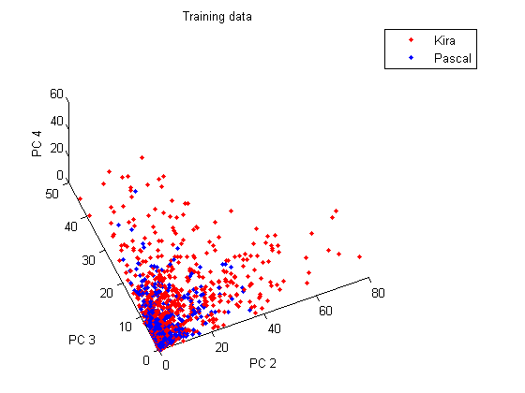

I feed these three principle components into a three layered backprop network, which produced the following output (the target vector was 0 for Kira, 1 for Pascal):

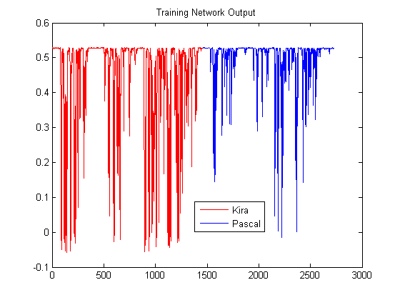

While most time points are not classified well (which is to be expected), it is clear that Kira’s data has more low values near 0 than Pascal’s data does. I created a score for each training set, which was the proportion of network classification values under 0.3:

Kira score = 15.4% Pascal score = 3.4%

While the network output values and the specific scores above changed each time I trained the network, Kira’s score was always much higher than Pascal’s.

Test data

I then projected the test data onto the same PC basis I determined for the training data. One of the test datasets was much more widely dispersed in PC space than the other.

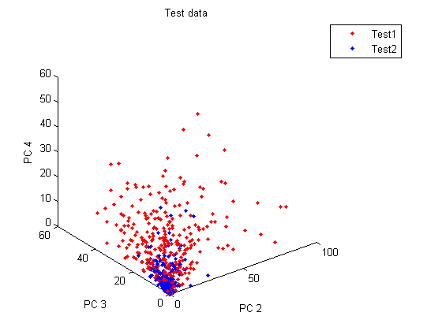
When I fed these as input into the network created before, I got the following output:
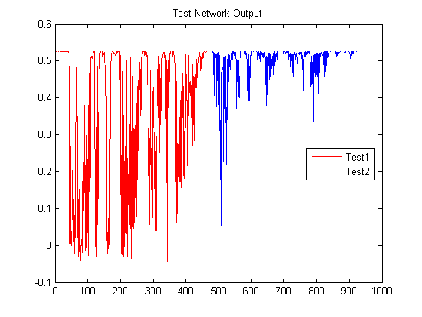
Like before, I can compute a score, which is the proportion of network classification values under 0.3:
Test 1 score = 35.1% Test 2 score = 1.3%

Clearly the Test 1 data belongs to Kira, and the Test 2 data belongs to Pascal.

